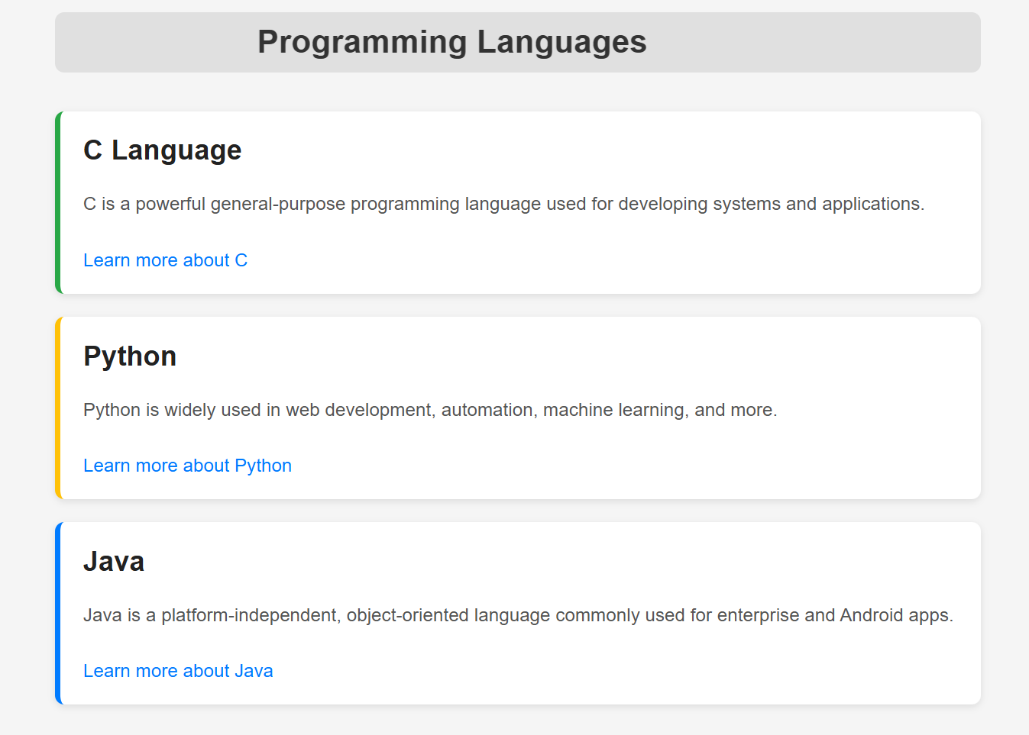

Practical: - To create a webpage showing info about different programming languages
<!DOCTYPE html>
<html lang="en">
<head>
<meta charset="UTF-8" />
<meta name="viewport" content="width=device-width, initial-scale=1.0"/>
<title>Programming Languages</title>
<style>
body {
font-family: Arial, sans-serif;
background-color: #f5f5f5;
margin: 0;
padding: 20px;
}
.container {
max-width: 800px;
margin: auto;
}
marquee {
font-size: 28px;
font-weight: bold;
color: #333;
margin-bottom: 30px;
background-color: #e0e0e0;
padding: 10px;
border-radius: 8px;
}
.language-card {
background-color: #fff;
border-left: 5px solid #007bff;
border-radius: 8px;
padding: 20px;
margin-bottom: 20px;
box-shadow: 0 2px 6px rgba(0, 0, 0, 0.1);
}
.language-card:nth-child(2) {
border-left-color: #28a745;
}
.language-card:nth-child(3) {
border-left-color: #ffc107;
}
.language-card h2 {
margin-top: 0;
color: #222;
}
.language-card p {
color: #555;
line-height: 1.6;
}
.learn-more {
display: inline-block;
margin-top: 10px;
color: #007bff;
text-decoration: none;
}
.learn-more:hover {
text-decoration: underline;
}
</style>
</head>
<body>
<div class="container">
<marquee behavior="scroll" direction="left">Programming Languages</marquee>
<div class="language-card">
<h2>C Language</h2>
<p>C is a powerful general-purpose programming language used for developing systems and applications.</p>
<a href="#" class="learn-more">Learn more about C</a>
</div>
<div class="language-card">
<h2>Python</h2>
<p>Python is widely used in web development, automation, machine learning, and more.</p>
<a href="#" class="learn-more">Learn more about Python</a>
</div>
<div class="language-card">
<h2>Java</h2>
<p>Java is a platform-independent, object-oriented language commonly used for enterprise and Android apps.</p>
<a href="#" class="learn-more">Learn more about Java</a>
</div>
</div>
</body>
</html>

